**N CHANNEL MOS AUDIO AMPLIFIER IN**

**ANALOG CIRCUIT**

Designing and implementing an N-channel MOSFET audio amplifier involves several steps, including circuit design, simulation, and hardware implementation. Below is a detailed guide on the process, including the use of software tools like Tinker CAD and Easy EDA.

**Step 1:** Understand the Circuit Design

An N-channel MOSFET audio amplifier typically involves:

- A power supply

- Input signal (audio source)

-MOSFET as the main amplification component

- Biasing resistors

- Capacitors for coupling and decoupling

- Load (speaker)

**Step 2**: Circuit Schematic Design

Components Needed:

1. *N-channel MOSFET* (e.g., IRF540N)
2. *Resistors* (various value for biasing)
3. *Capacitors*(for coupling and bypassing)
4. *Audio input source*
5. Power supply (12V-24V DC, depending on the MOSFET and desired output power)
6. Speaker

**Basic Circuit Layout:**

* *Drain* of the MOSFET connects to the positive power supply through the load(speaker).

- *Source* of the MOSFET is connected to ground.

- *Gate* is biased using a voltage divider network.

* *Coupling capacitor* connects the audio signal to the gate of the MOSFET.
* *Bypass capacitor* is placed across the source resistor to stabilize the operating point.

**Step 3**: Simulation in Tinker CAD

1. Create a New Project : Log in to Tinker CAD and create a new project.
2. Add Components : Add a breadboard, MOSFET, resistors, capacitors, and other components from the components library.
3. Connect Components: Wire the components according to the schematic design.
4. Simulate : Run the simulation to check if the amplifier works correctly. Observe the output waveform using the oscilloscope tool within Tinker CAD.

**RESULT OF TINKERCAD**

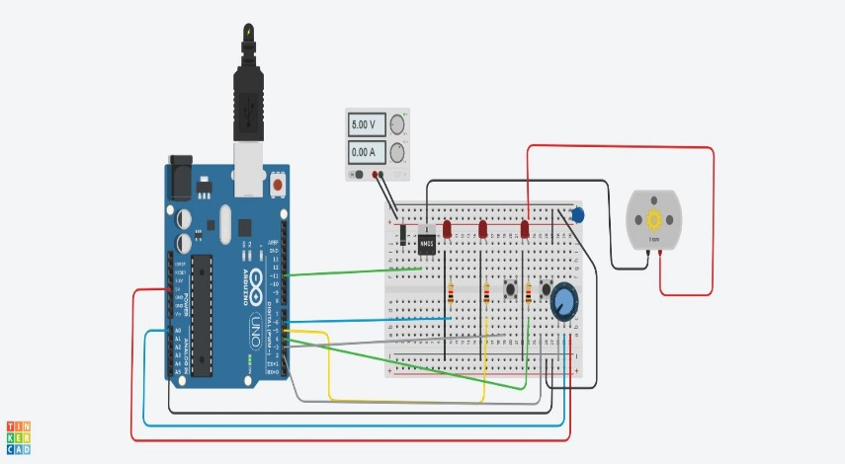

**Step 4:**  PCB Design in EasyEDA

1. Create a New Project : Log in to EasyEDA and create a new project.
2. Draw Schematic:

- Use the schematic capture tool to draw the circuit diagram.

- Place the components and connect them according to the schematic.

1. Design PCB Layout :

- Convert the schematic to PCB.

- Place the components on the PCB layout.

- Route the traces manually or use the auto-router.

- Ensure proper grounding and trace width for power handling.

1. Generate Gerber Files: Once the design is complete, generate the Gerber files necessary for PCB manufacturing.

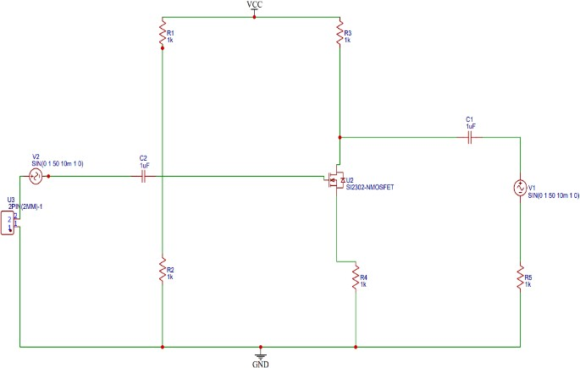

**PCB CIRCUIT**

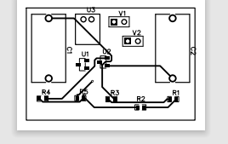

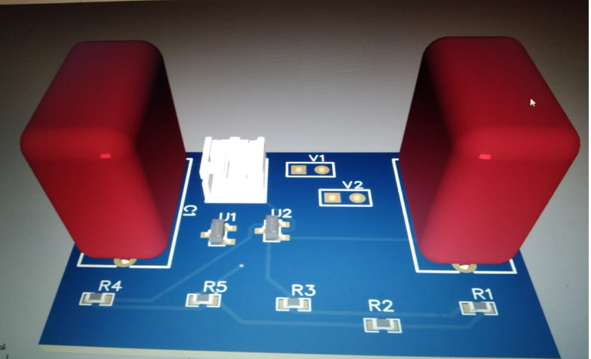

**3D CIRCUIT**

**Step 5:** Hardware Implementation

1. Procure Components : Obtain the required components based on your design.
2. Assemble on Breadboard : Before moving to PCB, it is often useful to assemble the circuit on a breadboard to test functionality.
3. Test : Power up the circuit and test with an audio input. Use an oscilloscope to check the output waveform.
4. Assemble on PCB : If the breadboard test is successful, proceed to solder the components on to the PCB.
5. Final Testing : Perform final testing with the PCB assembled circuit. Connect it to the audio source and speaker to ensure it functions as expected.

**Step-by-Step Procedure**

1. Schematic Design :

- Use Easy EDA to create a schematic.

- Place components: MOSFET, resistors, capacitors.

- Connect components to form the amplifier circuit.

1. Simulation :

- Simulate the circuit in Tinker CAD to verify the design.

- Make adjustments as needed based on simulation results.

1. PCB Design :

- Design the PCB layout in Easy EDA.

- Ensure proper placement of components and routing of traces.

- Export Gerber files for manufacturing.

1. Breadboard Testing :

- Assemble the circuit on a breadboard.

- Test with an actual audio signal.

1. PCB Assembly:

- Solder components on to the fabricated PCB.

- Test the final assembly with audio input and a speaker.

1. Final Adjustments:

- Make any necessary adjustments to component values for optimal performance.

- Ensure the amplifier is stable and produces clear sound.

**Group Candidates Are**:

Salomi.s-BU22EECE0200006

Karthik.s-BU22EECE0200007

Ch.Pavankumar-BU22EECE0200014

N.Rakshitha-BU22EECE0200019